Ifeanyi Fabian Ugwu

Electronics Design & Simulation Portfolio

KiCad | LTSpice | NGSpice | PCB Design | AI Hardware Prototyping

Calgary Alberta, Canada
ifeanyiugwu33@outlook.com
+1 438 871-2598

PROFESSIONAL SUMMARY

Electronics Design and Technical Operations Professional with hands-on experience supporting telecommunications infrastructure, computer networking systems, CCTV deployment, access control systems, and electronic hardware integration. Skilled in schematic design, circuit simulation, PCB layout development, and hardware validation using industry-standard electronic design tools.

Passionate about applying KiCad, LTSpice, and NGSpice to develop intelligent hardware systems for AI research, IoT devices, embedded systems, and telecom applications. Experienced in translating engineering requirements into functional electronic designs through simulation, prototyping, PCB design, and manufacturing documentation.

Core competencies include:

Schematic Capture

PCB Layout Design

Circuit Simulation

Design for Manufacturing (DFM)

Component Selection

Gerber Generation

Hardware Validation

Embedded Hardware Development

Technical Documentation

PROJECT 1

AI Environmental Monitoring Sensor Node

Project Overview
Designed a low-power environmental monitoring system intended to collect temperature, humidity, and air quality data for AI-driven predictive analytics.

Objective
Develop a reliable sensor acquisition board capable of providing clean and accurate data to machine-learning models used for environmental forecasting.
Tools Used

KiCad 9.0

LTSpice

NGSpice

Design Process

Schematic Design

Created multi-sheet schematics containing:

Power Supply Section

ESP32 Microcontroller

Environmental Sensors

Communication Interface

Protection Circuitry

Circuit Simulation

Used LTSpice to validate:

Voltage regulator performance

Sensor power filtering

Startup behavior

Power consumption characteristics

PCB Development

Designed a 4-layer PCB featuring:

Ground Plane Optimization

EMI Reduction

Compact Component Placement

Thermal Relief Implementation

Key Challenges

Noise interference affecting sensor accuracy

Power consumption optimization

Compact PCB footprint requirements

Solutions

Added LC filtering network

Optimized ground return paths

Improved decoupling capacitor placement

Deliverables

✔ Complete KiCad Project
✔ Manufacturing Gerbers
✔ BOM Documentation
✔ PCB 3D Render
✔ Simulation Reports

Screecshot of PCB Monitoring Sensor Node
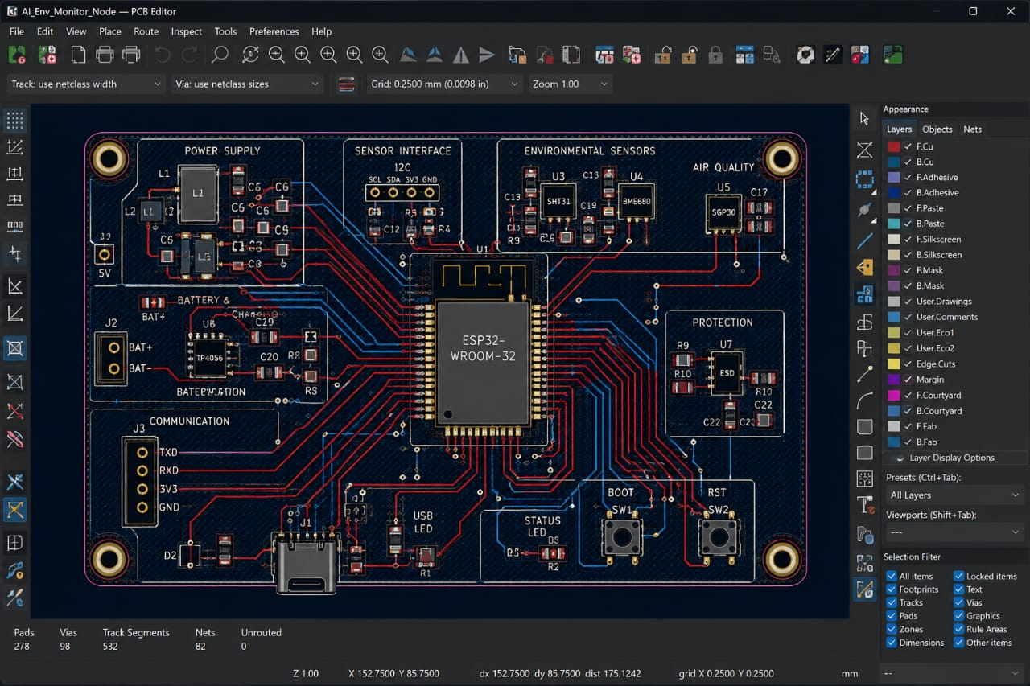

PROJECT 2

AI Edge Vision Processing Power Module

Project Overview

Designed a power delivery subsystem for an AI edge-computing platform utilizing embedded processors for computer vision applications.

Objective

Provide stable and efficient power rails for high-performance AI processing hardware.

Tools Used

KiCad

LTSpice

NGSpice

Design Features

Buck Converter Design

Overcurrent Protection

Reverse Polarity Protection

Thermal Monitoring Circuit

Simulation Activities

Validated:

Output Voltage Ripple

Load Transients

Thermal Stability

Switching Efficiency

Challenges

High processor current demand

Heat generation

Voltage instability during peak load

Engineering Solutions

Optimized switching regulator design

Added thermal vias

Increased copper pour areas

Results

Stable operation under full load

Reduced voltage ripple

Improved efficiency

Deliverables

✔ Schematic Package
✔ PCB Layout
✔ Simulation Results
✔ Manufacturing Files

Screenshot of a PCB Processing Power Module
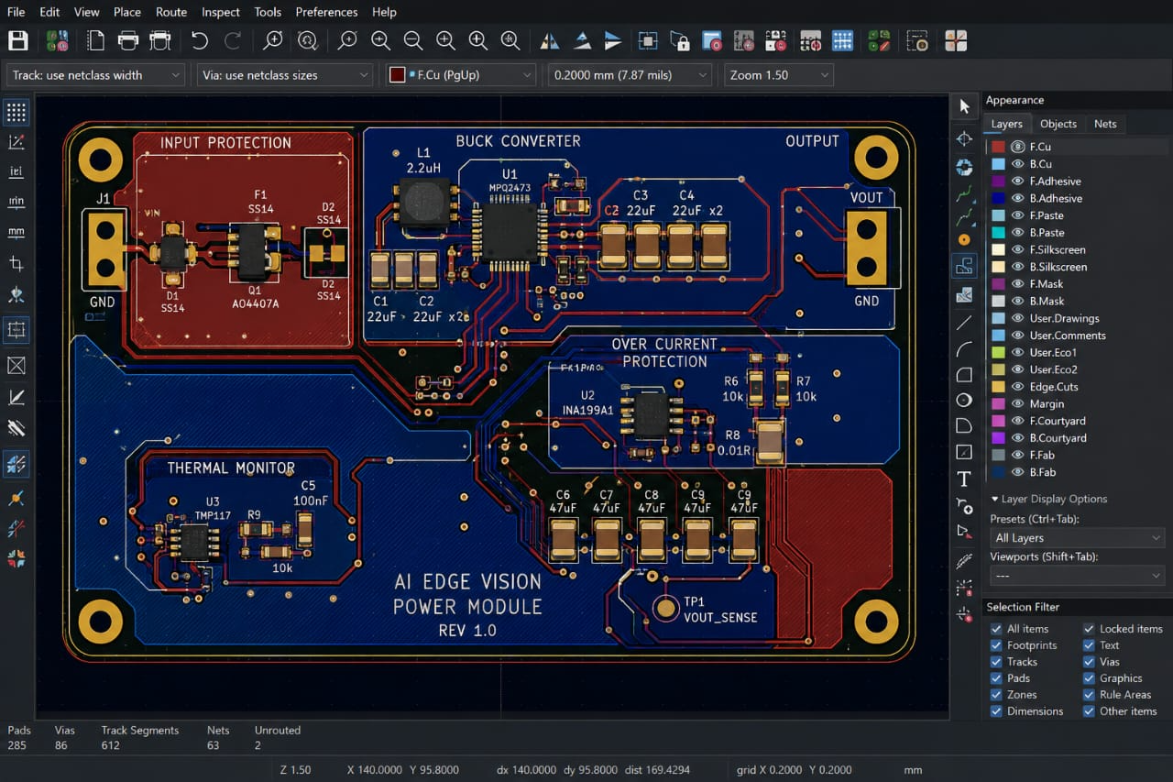

PROJECT 3

Intelligent Access Control System

Project Overview

Developed an AI-ready access control hardware platform inspired by real-world deployments of automated doors and security systems.

Objective

Create a hardware platform capable of supporting facial recognition and smart authentication systems.

Tools Used

KiCad

LTSpice

NGSpice

Hardware Components

RFID Reader Interface

Relay Driver Circuit

Backup Power System

Communication Interface

Door Control Module

KiCad Features Utilized

Hierarchical Schematics

Custom Symbols

Custom Footprints

Design Rule Checking

3D Visualization

Challenges

Relay-induced noise

Voltage spikes

Reliability concerns

Solutions

Flyback Protection Circuitry

EMI Filtering

Ground Segmentation

Results

Reliable switching performance

Improved hardware protection

Manufacturing-ready PCB

Screenshot of PCB Intelligent Access Control System
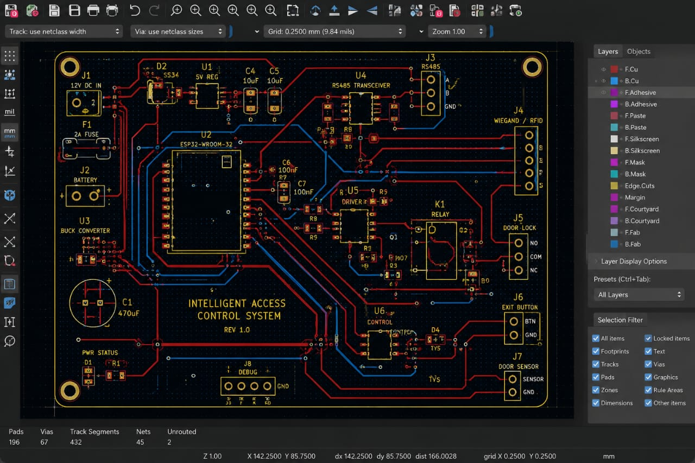

Deliverables

✔ PCB Layout
✔ Gerber Files
✔ Assembly Documentation
✔ BOM
✔ Test Report

TECHNICAL SKILLS

Electronics Design

KiCad

LTSpice

NGSpice

Schematic Capture

PCB Layout

Multi-Layer PCB Design

PCB Stack-Up Planning

Simulation

Analog Simulation

Power Supply Simulation

Transient Analysis

Frequency Response Analysis

Thermal Evaluation

Manufacturing

DFM

DFA

Gerber Generation

BOM Preparation

Assembly Documentation

Prototype Validation

Hardware Development

Embedded Systems

IoT Hardware

Sensor Integration

Power Electronics

Analog Circuits

Digital Circuits

ATS KEYWORDS

KiCad, LTSpice, NGSpice, PCB Design, PCB Layout, Hardware Engineering, Electronic Circuit Design, Schematic Capture, DFM, DFA, Signal Integrity, Power Integrity, Embedded Systems, IoT Hardware, Gerber Generation, Hardware Validation, PCB Manufacturing, Analog Electronics, Digital Electronics, Power Supply Design, ESP32, Microcontroller Design, Design Verification, Engineering Documentation, AI Hardware Development, Edge Computing, Custom Footprints, Multi-Sheet Schematics, Design Rule Checking, Electrical Rule Checking, EMI Mitigation, Hardware Prototyping.

